MAHATMA EDUCATION SOCIETY’S

PILLAI COLLEGE OF ARTS, COMMERCE & SCIENCE

(Autonomous)

NEW PANVEL

PROJECT REPORT ON

CRIME RATE ANALYSIS ACROSS INDIA

IN PARTIAL FULFILLMENT OF

BACHELOR OF SCIENCE  IN INFORMATION TECHNOLOGY

SEMESTER    IV  – 2023-24

PROJECT GUIDE

Name : PRADNYA KUMAVAT MAM

SUBMITTED BY: SANDEEP NIRMAL

ROLL NO: 6245

NAME : SANDEEP NIRMAL

ROLL NO : 6245

CLASS : SYIT

DIVISION  : ( C )

FACULTY : PRADNYA KUMAVAT

SUBJECT : DATA SCIENCE

TOPIC : CRIME RATE ANALYSIS ACROSS INDIA.

**INTRODUCTION**

**Crime rate analysis is a crucial aspect of understanding the socio-economic landscape and public safety dynamics within a country. In this analysis, we explore various crime-related datasets with a focus on India. The objective is to derive meaningful insights into the distribution, trends, and patterns of different types of crimes across different regions of the country. The datasets encompass a wide array of crime categories, providing a comprehensive view of the law enforcement landscape.**

**Dataset Overview:**

* **The datasets used in this analysis comprise information related to diverse criminal activities reported across various States and Union Territories of India. The variables include but are not limited to murder, attempt to murder, dacoity, riots, burglary, cheating, assault on women, and other criminal offenses as per the Indian Penal Code (IPC).**

**Exploratory Data Analysis (EDA):**

* **Univariate Analysis:**
  + **Initial exploration involves Analysing individual crime categories to understand their distributions, frequencies, and potential outliers.**
  + **Descriptive statistics and visualizations, such as histograms and bar plots, provide insights into the prevalence of different crimes.**
* **Bivariate Analysis:**
  + **Relationships between pairs of crime variables are examined to uncover potential correlations.**
  + **Scatter plots, hexbin plots, and correlation matrices assist in understanding the interplay between different types of crimes.**
* **Multivariate Analysis:**
  + **A multivariate approach involves exploring the relationships between multiple crime variables simultaneously.**
  + **Parallel coordinate plots offer a comprehensive visualization of crime profiles across different States and Union Territories.**
* **Geospatial Analysis:**
  + **Geographic variations in crime rates are visualized using maps, providing a spatial understanding of crime distribution.**
  + **This aids in identifying regions with higher or lower crime rates and supports targeted interventions.**

**Temporal Analysis:**

* **The temporal dimension is incorporated to analyse crime trends over different years, identifying patterns, and assessing the impact of time on crime rates.**



Output:

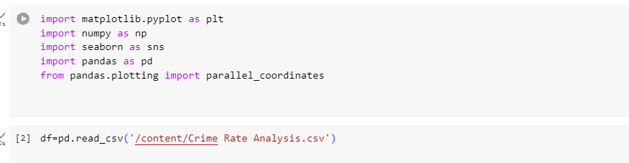

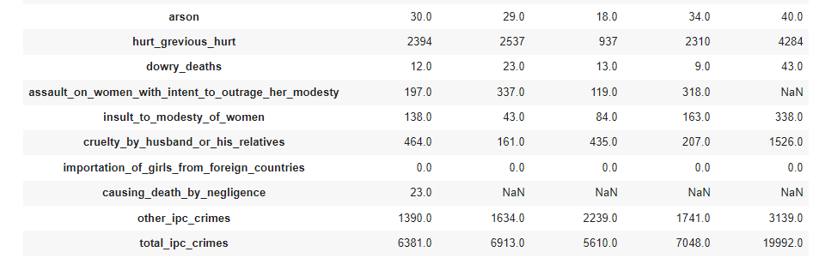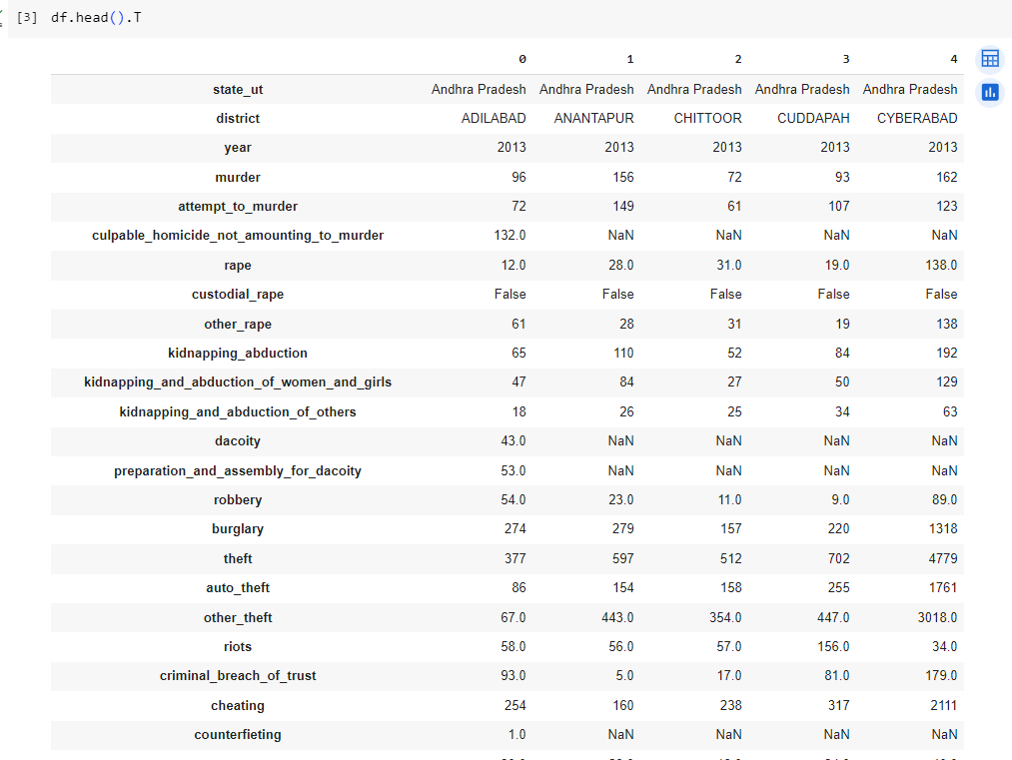

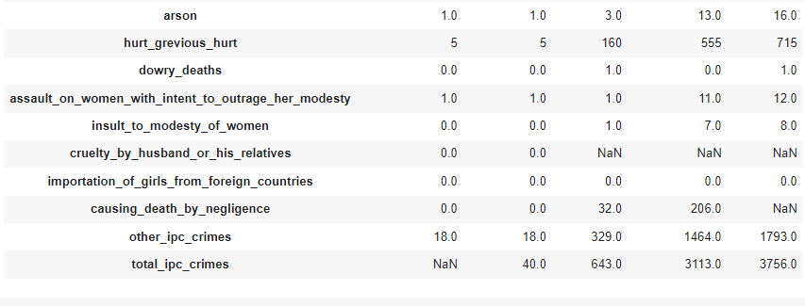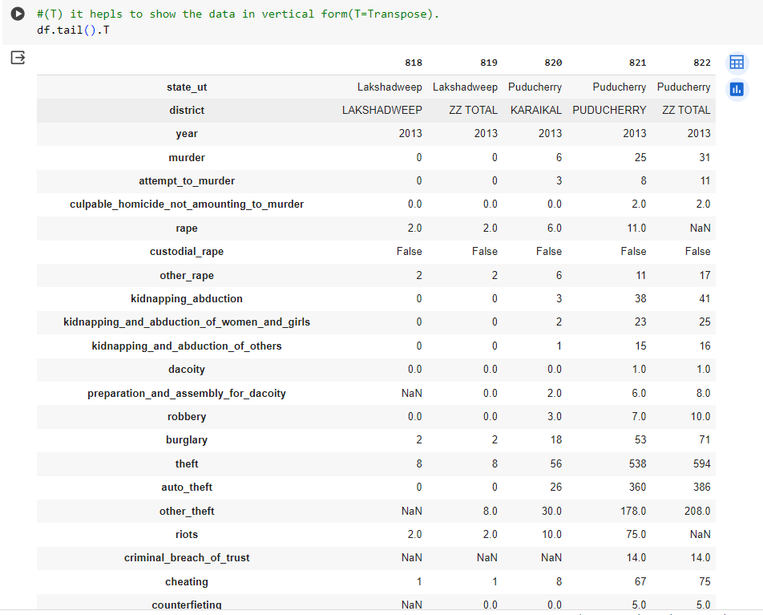

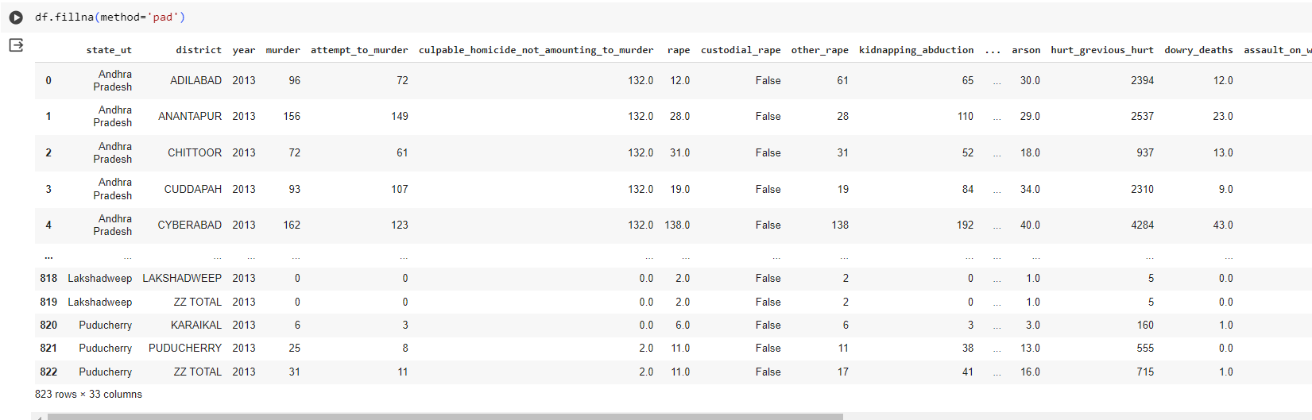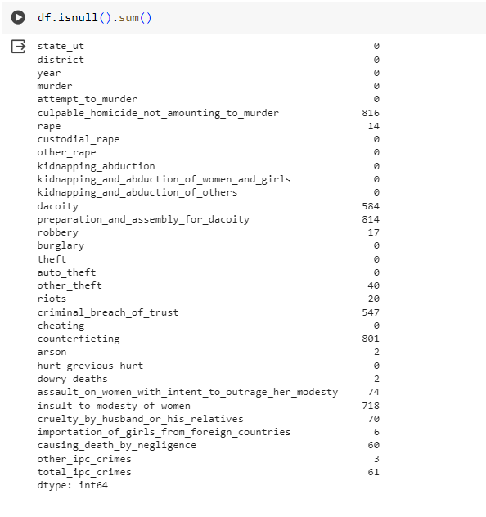

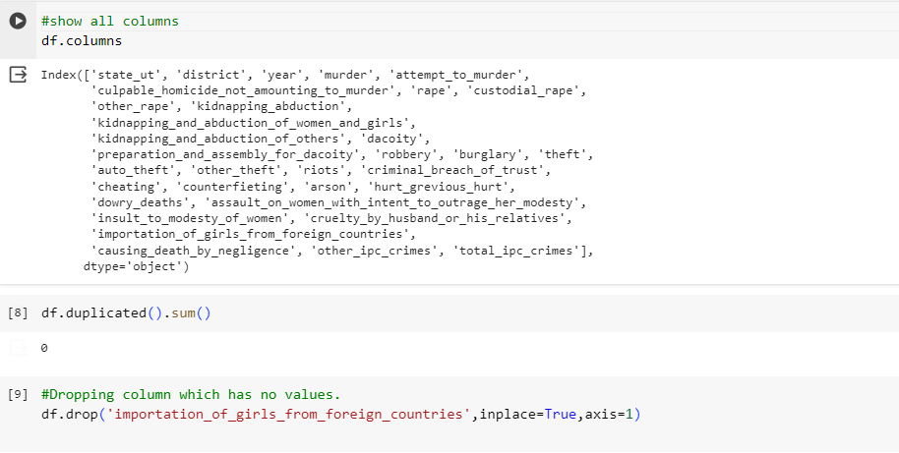

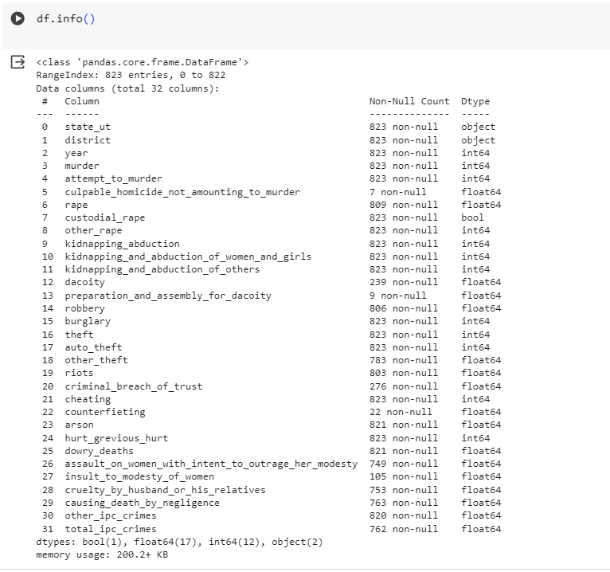

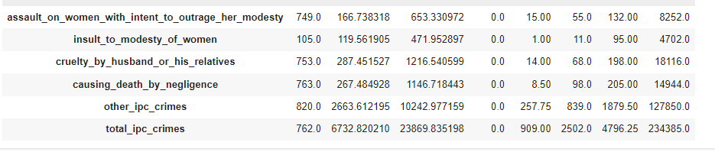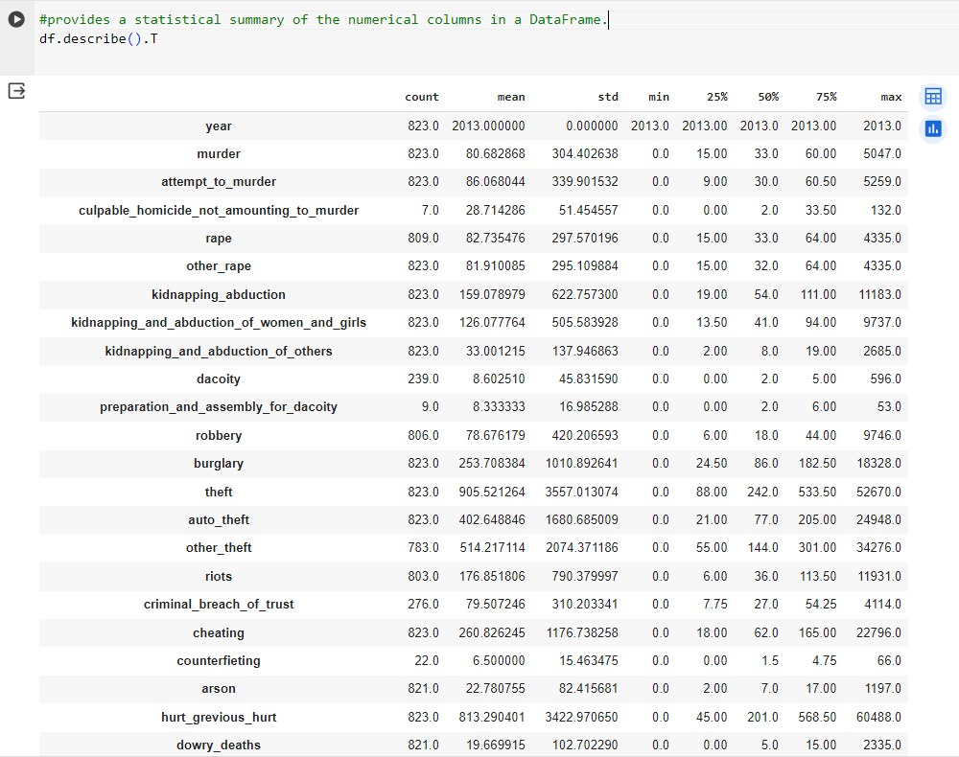

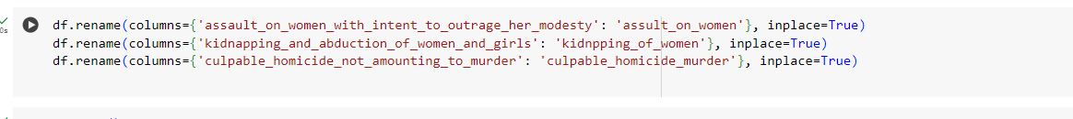

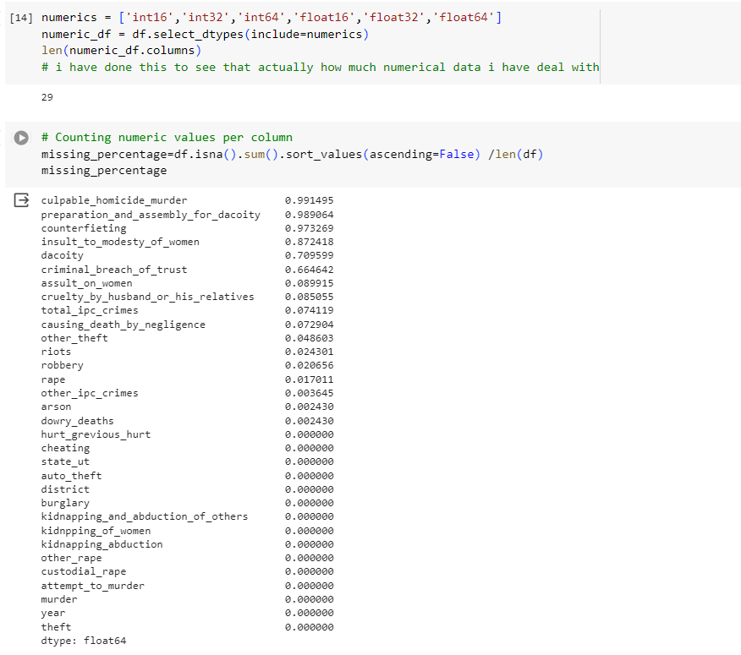

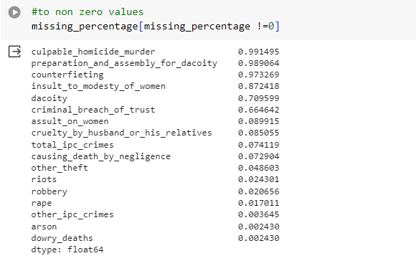

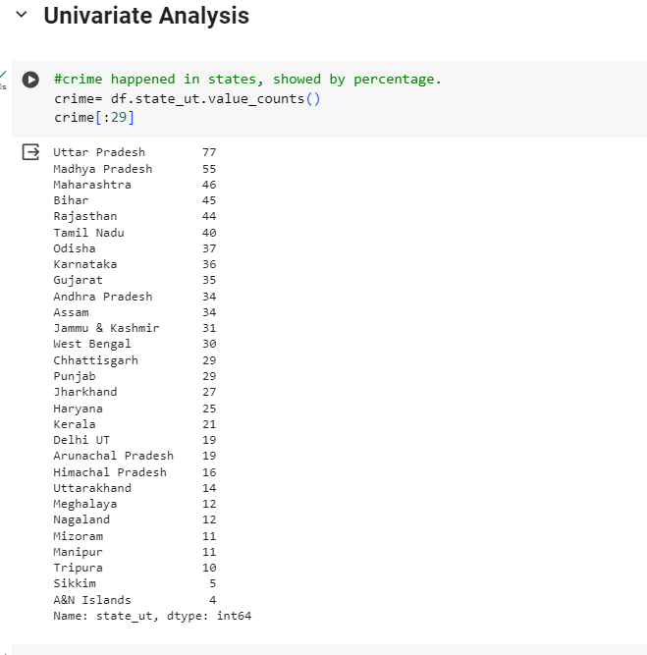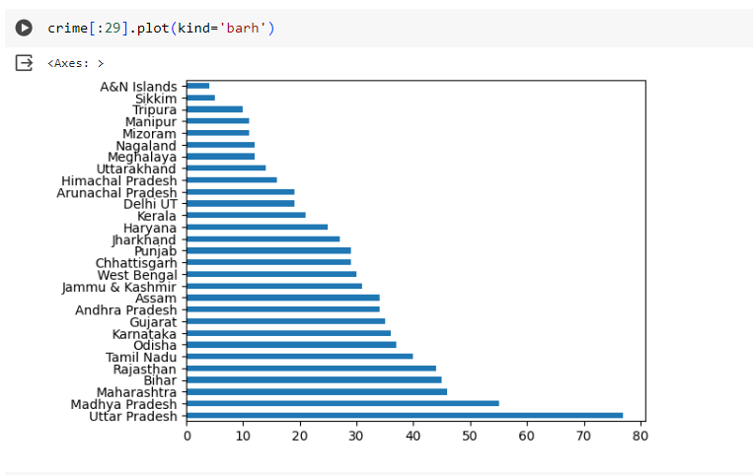

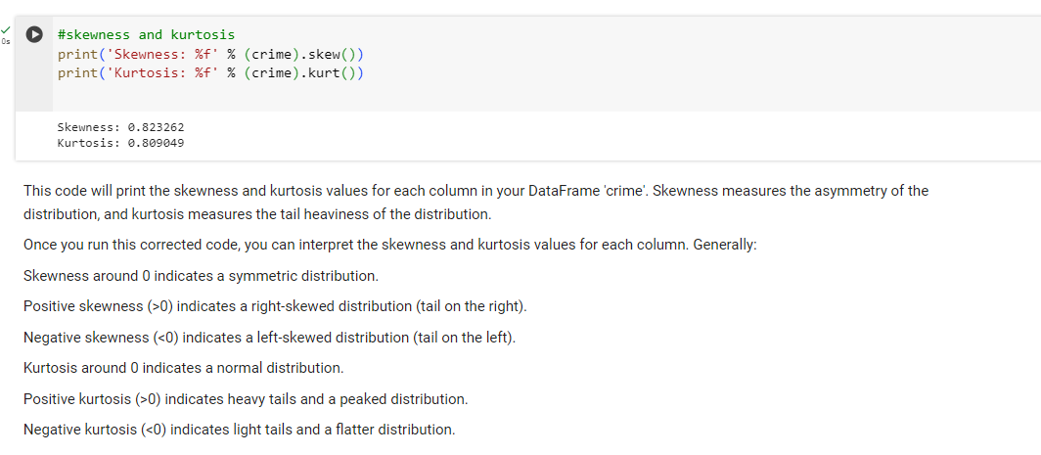

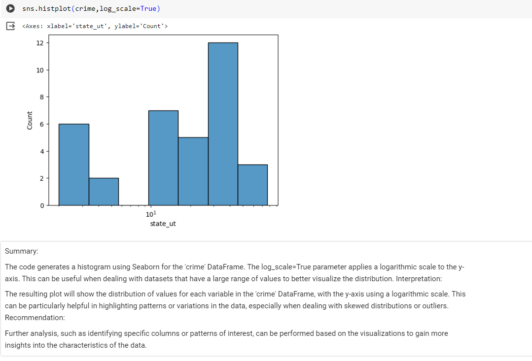

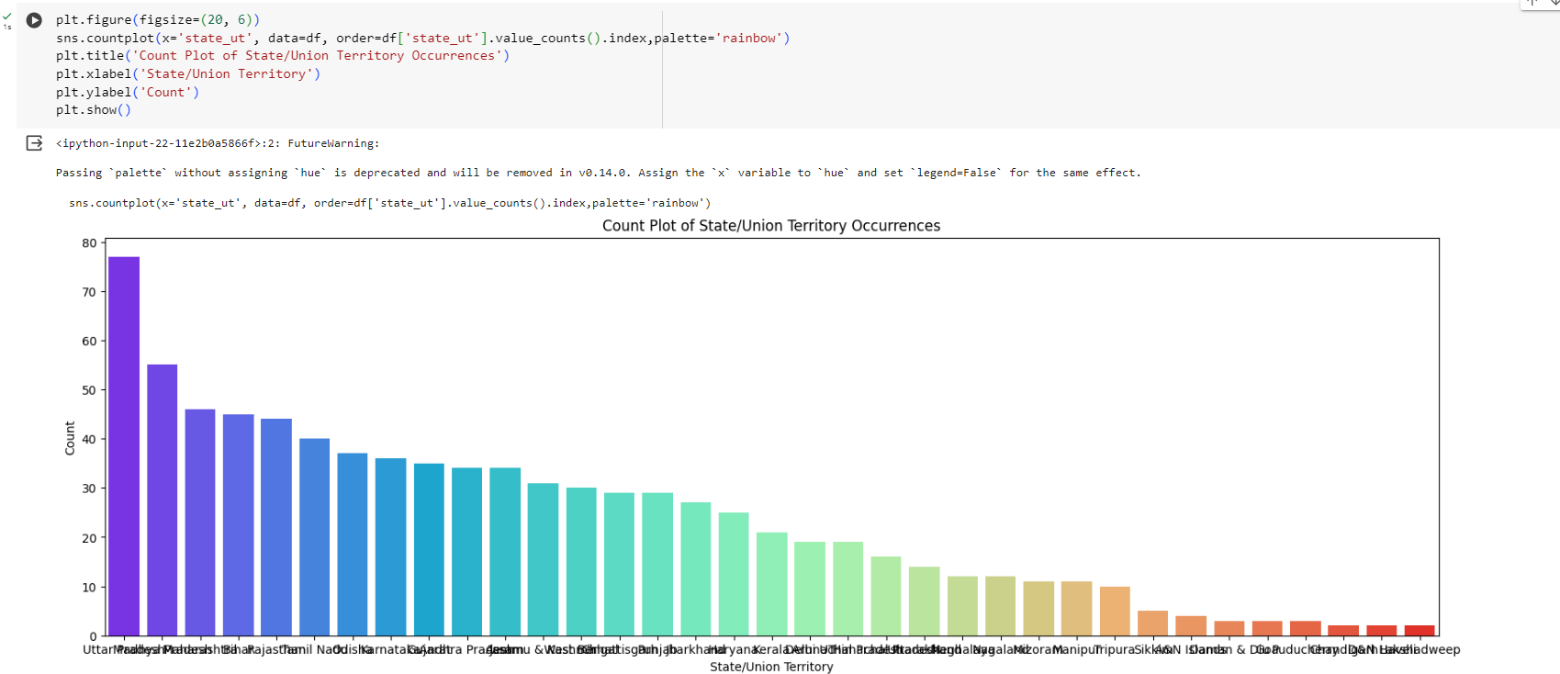

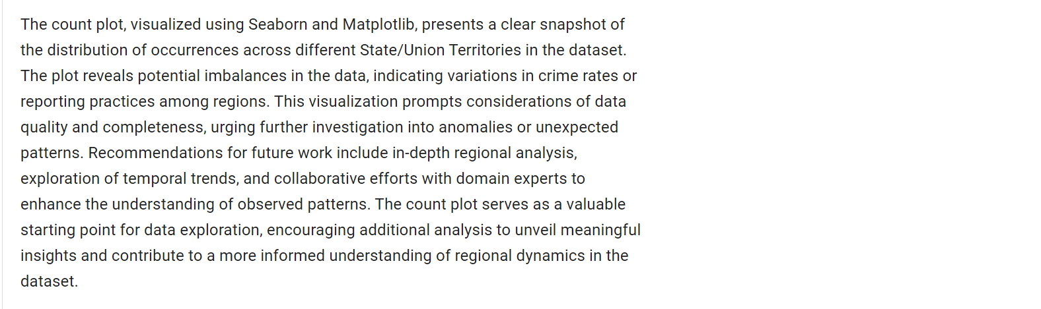

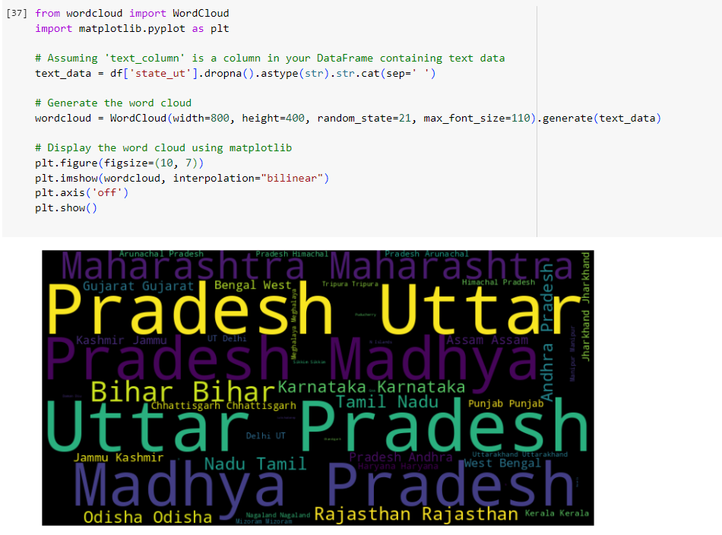

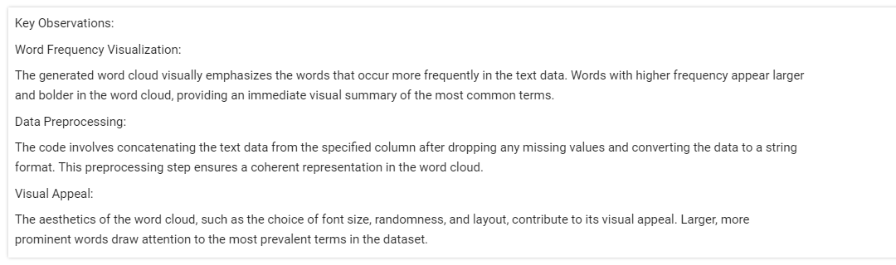

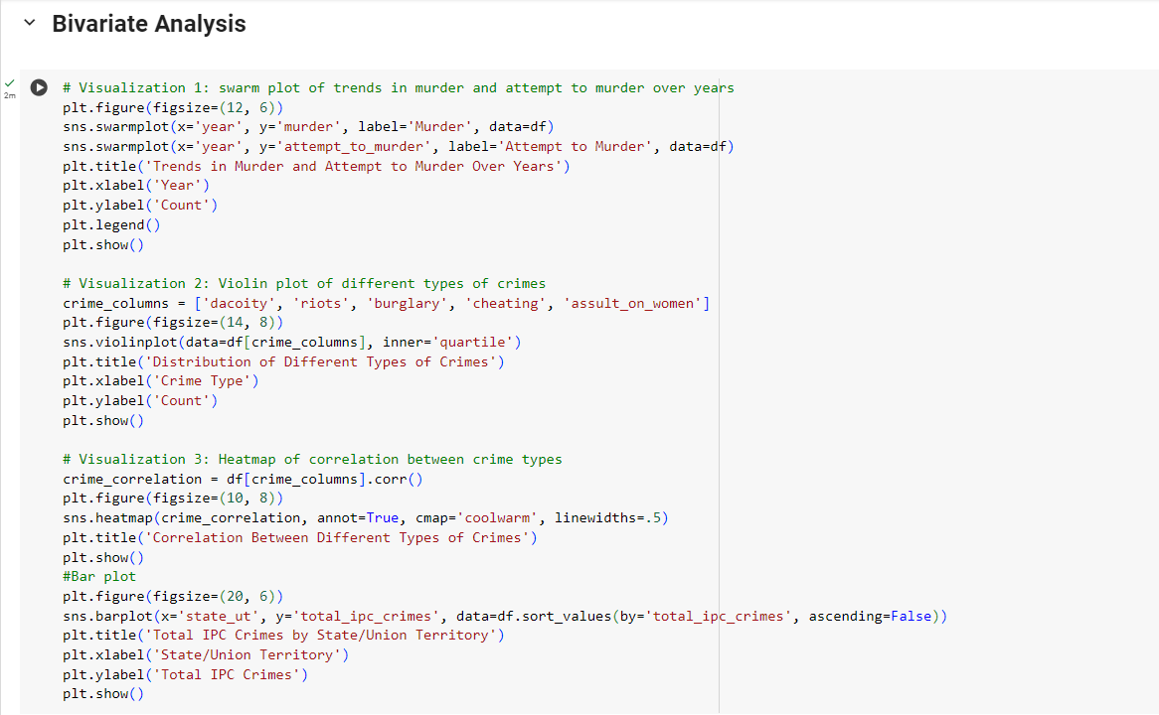

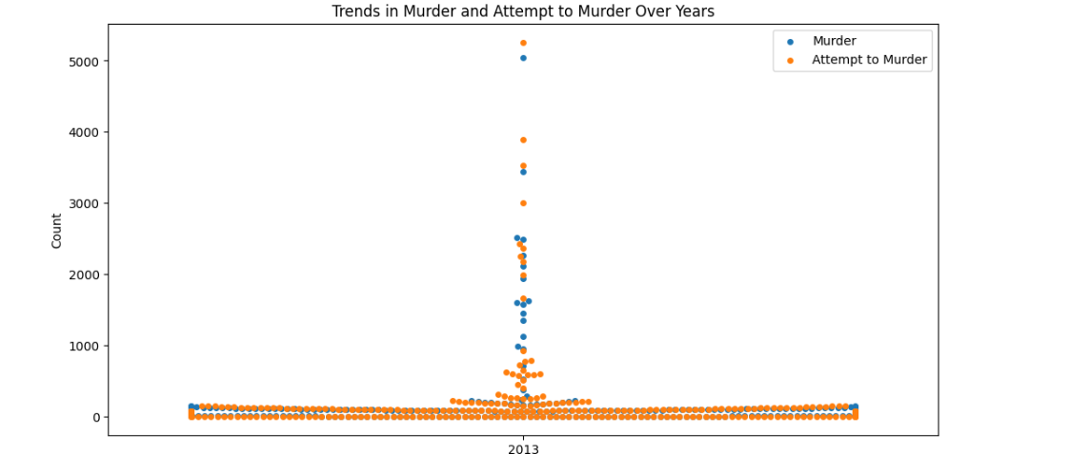

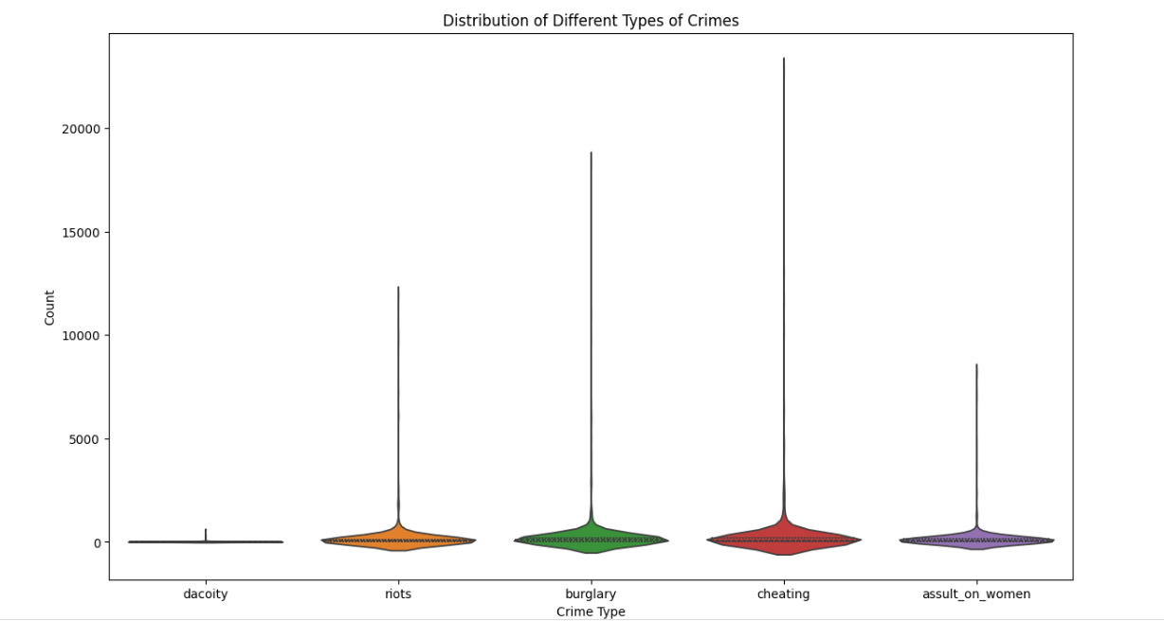

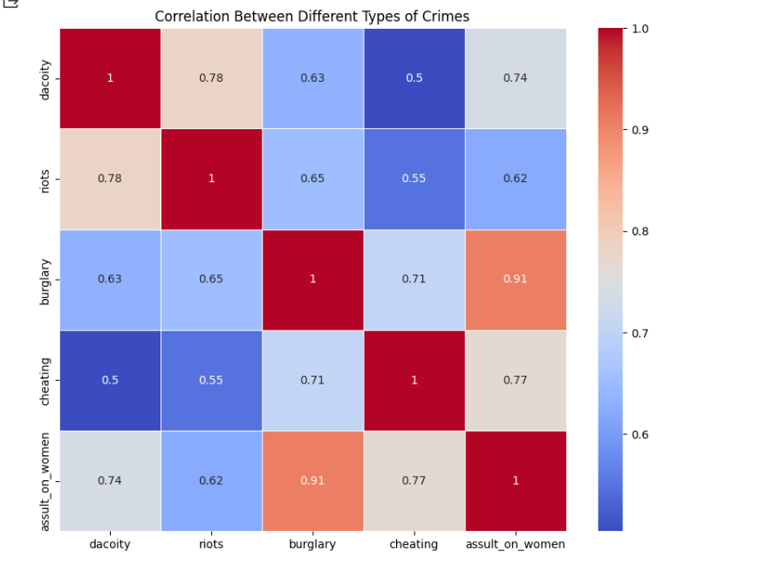

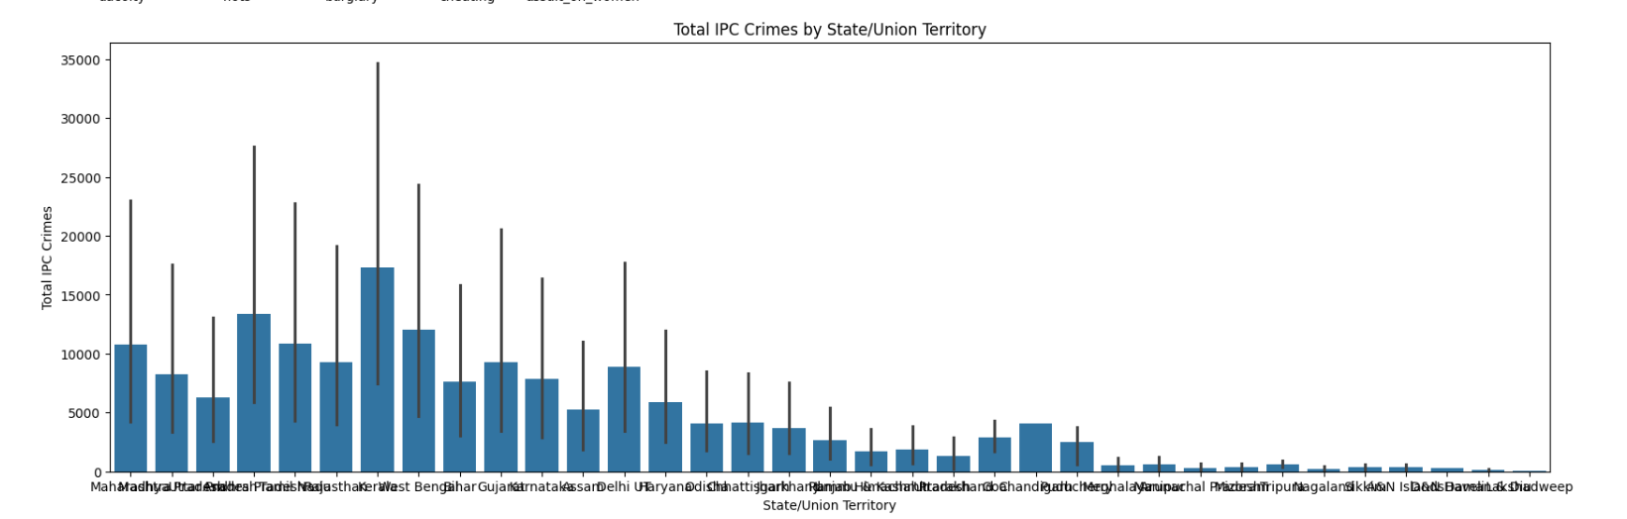

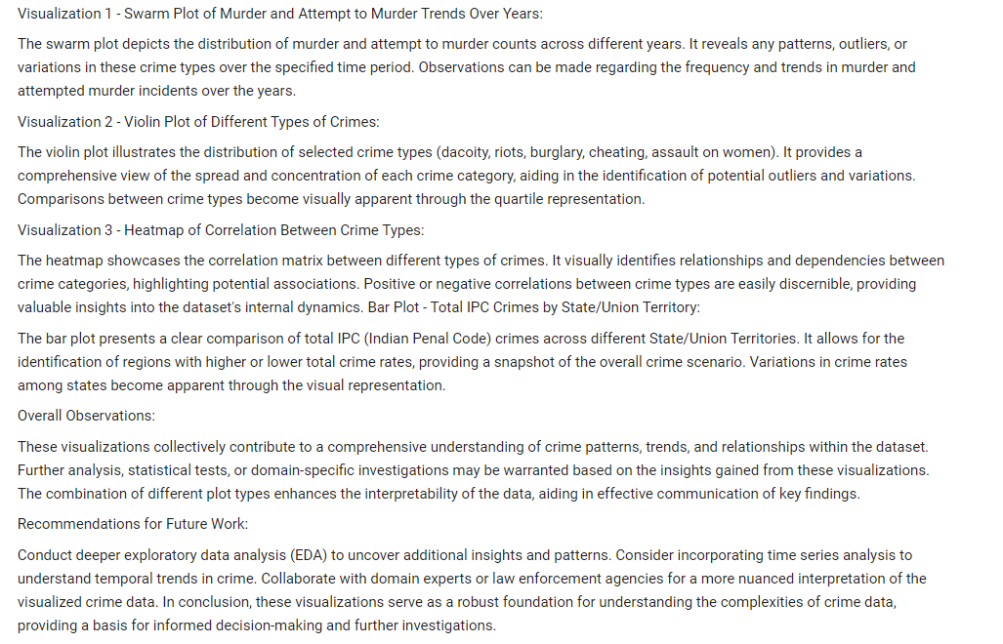

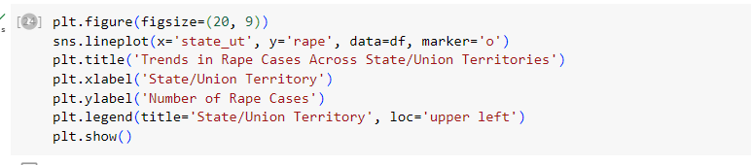

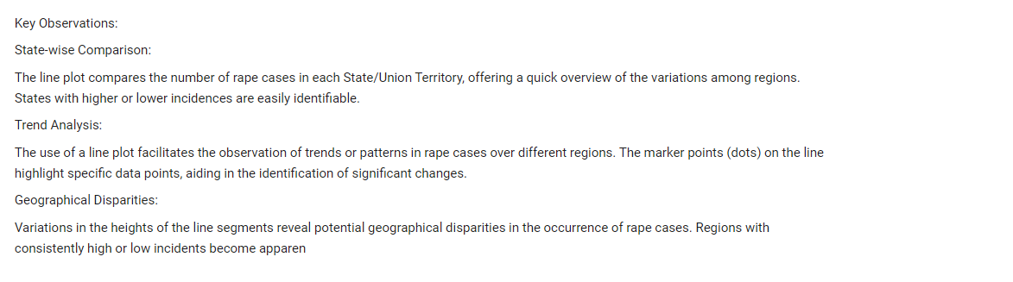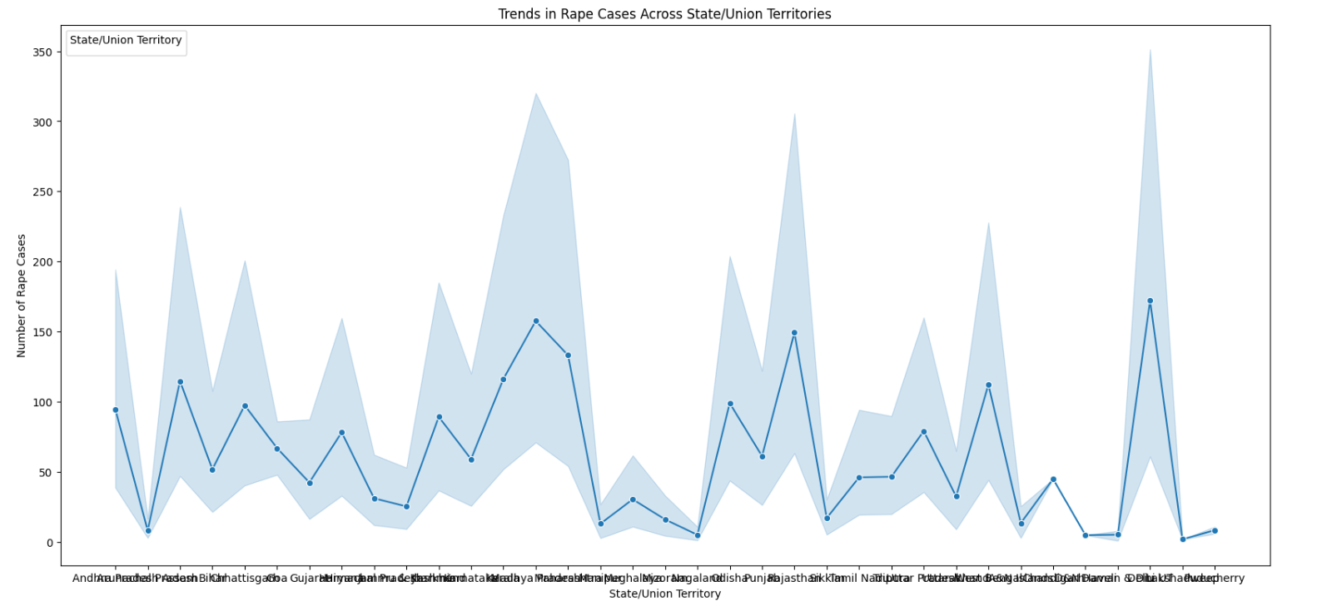

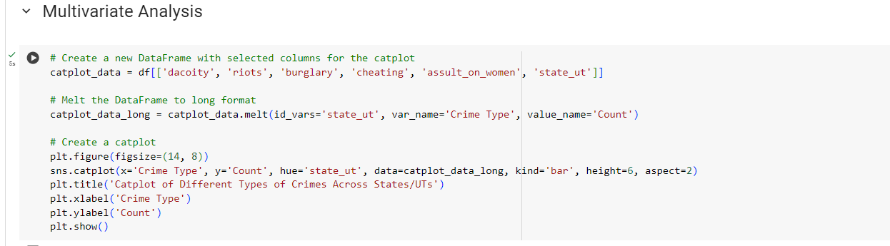

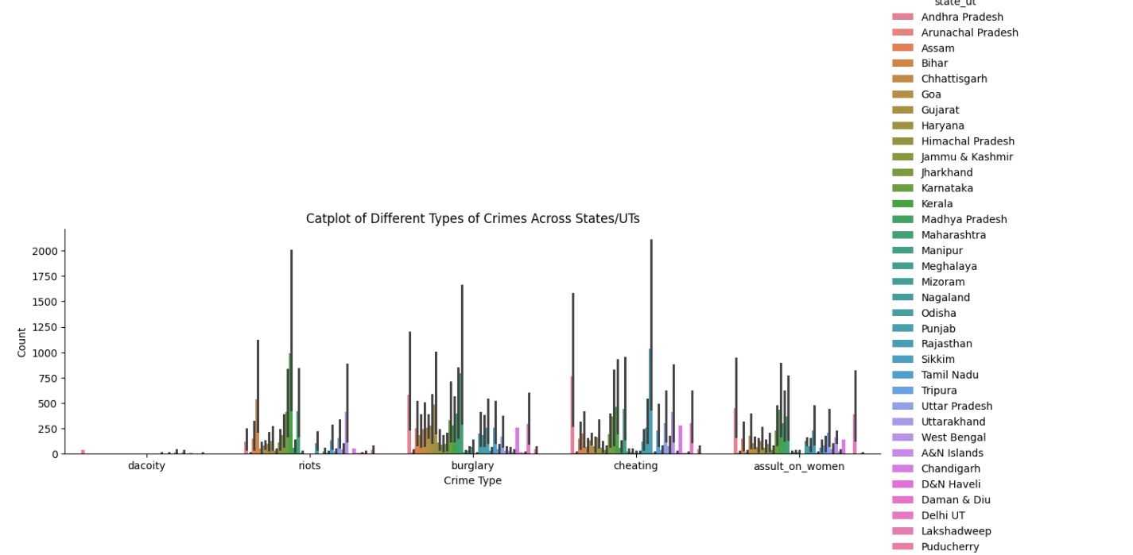

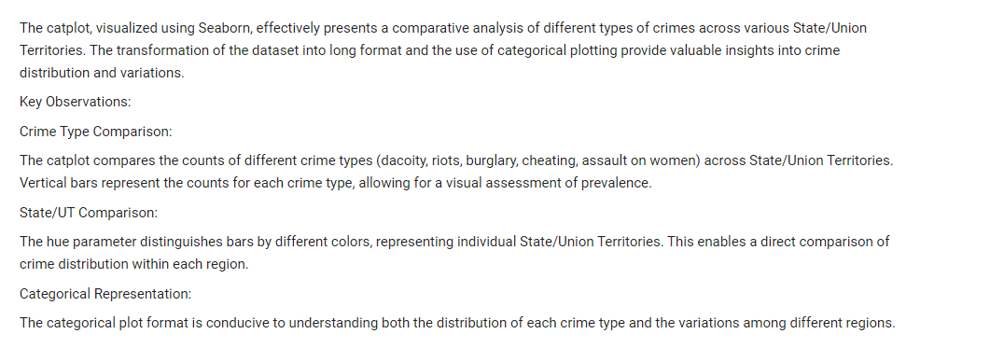

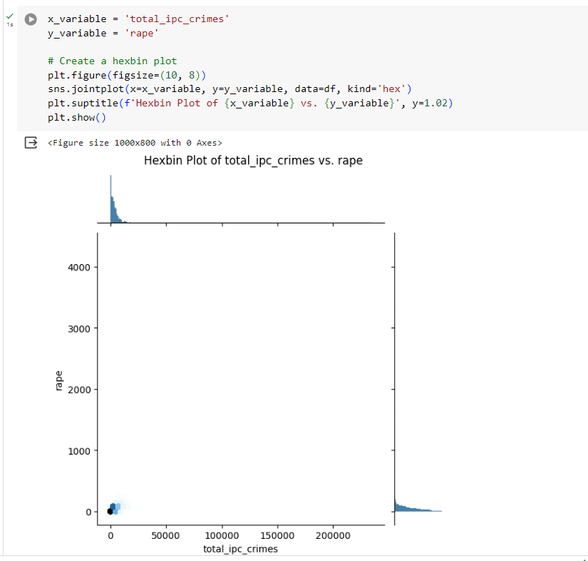

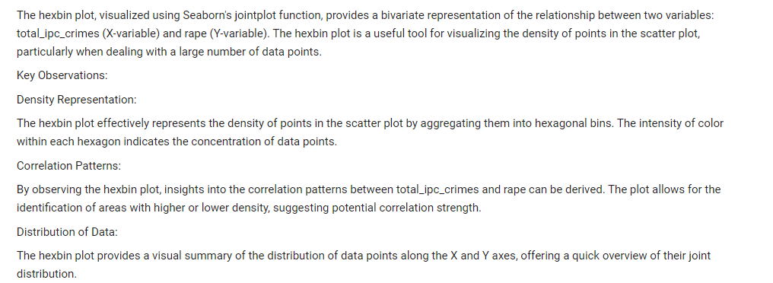

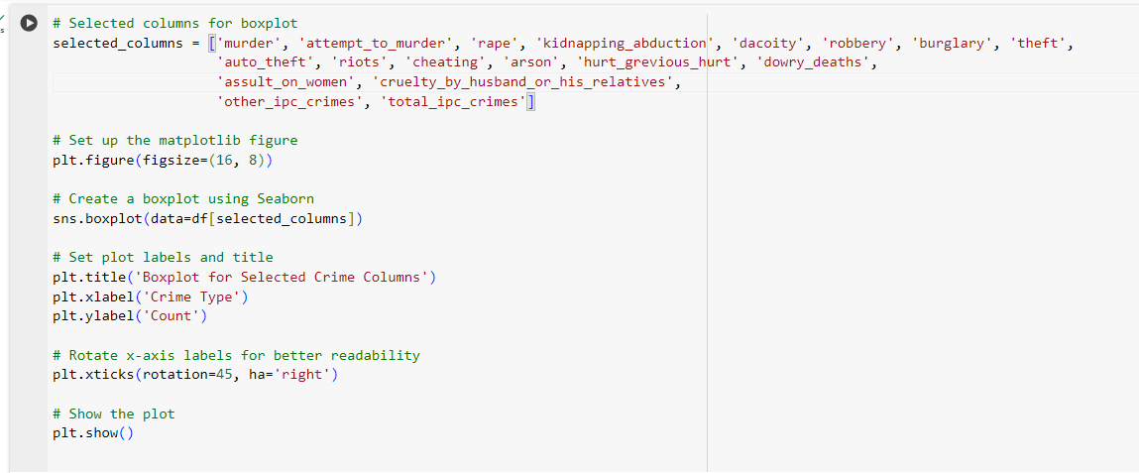

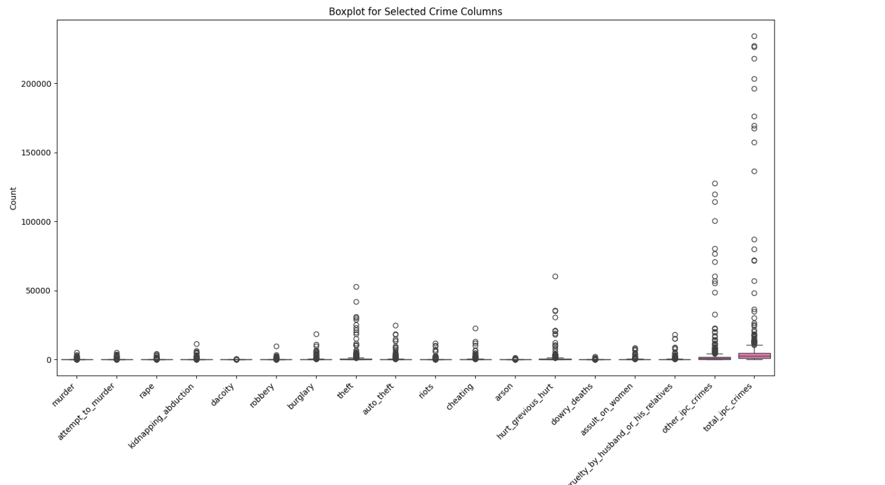

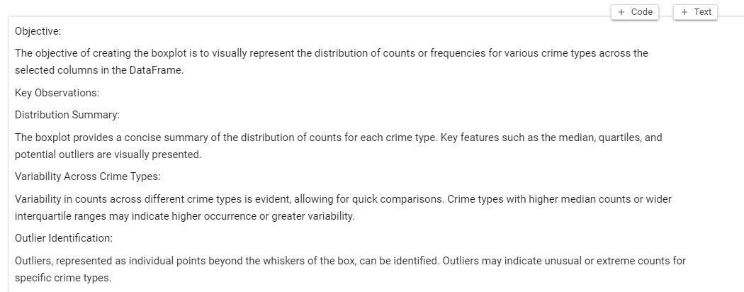

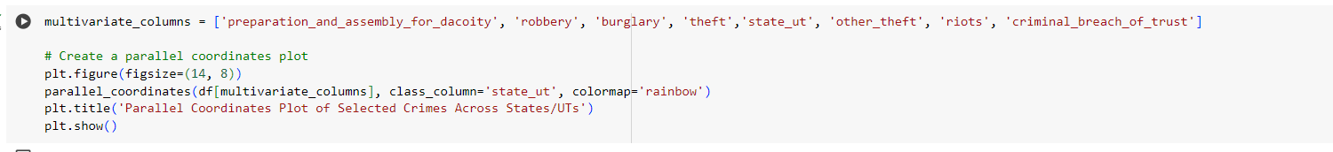

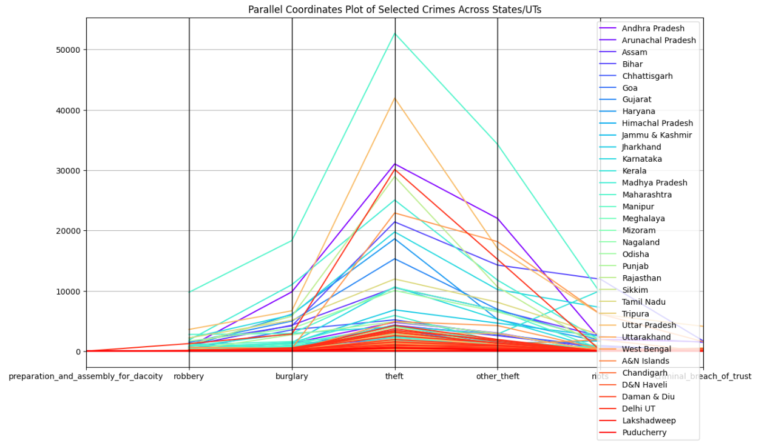

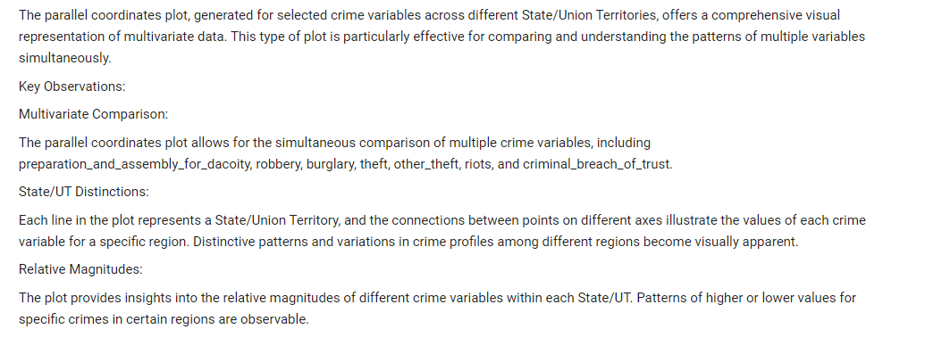

**Overview:**

The comprehensive set of code snippets provided for crime rate analysis across India involves exploratory data analysis (EDA), visualization, and statistical summary of crime-related datasets. The analysis covers a diverse range of crime types across various States and Union Territories, aiming to draw meaningful insights into the distribution, trends, and patterns of criminal activities.

**Key Findings and Observations:**

**Data Exploration:**

The initial data exploration involved descriptive statistics, checking for missing values, and understanding the structure of the dataset.

**Univariate Analysis:**

Visualizations such as histograms, distplots, and bar plots were utilized to understand the distribution and frequency of individual crime types.

Descriptive statistics, including skewness and kurtosis, provided insights into the shape and characteristics of the crime data.

**Bivariate Analysis:**

Relationships between pairs of crime variables were explored using scatter plots, hexbin plots, and correlation matrices.

This analysis helped identify potential correlations and dependencies between different types of crimes.

**Multivariate Analysis:**

A multivariate approach involved exploring the relationships between multiple crime variables simultaneously.

Visualizations like parallel coordinates plots were employed to provide a comprehensive view of crime profiles across States and Union Territories.

**Temporal Analysis:**

The temporal dimension was incorporated to analyze crime trends over different years, identifying patterns and assessing the impact of time on crime rates.

**Geospatial Analysis:**

Geographic variations in crime rates were visualized using maps, offering insights into the spatial distribution of crimes.

**Word Cloud Generation:**

A word cloud was created to visualize the frequency of words in text data, potentially highlighting common themes or prevalent terms.

**Boxplot Visualization:**

Boxplots were utilized to visually represent the distribution of counts for various crime types, aiding in the identification of central tendencies, variability, and potential outliers.

**Conclusion**:

The crime rate analysis provides a holistic understanding of the diverse landscape of criminal activities across India.

Variability in crime occurrence across States and Union Territories is evident, with certain regions experiencing higher rates for specific crime types.

Temporal trends highlight fluctuations in crime rates over the years, suggesting potential areas for further investigation.

The geospatial analysis contributes to a spatial understanding of crime distribution, aiding in the identification of high-risk regions.

Multivariate and bivariate analyses reveal potential correlations between different crime categories, providing insights into complex relationships.

**Recommendations:**

Further research could delve into specific crime categories, investigating factors contributing to high crime rates and proposing targeted interventions.

Continuous monitoring and analysis of crime data can support evidence-based policymaking and law enforcement strategies.

Collaboration with domain experts and stakeholders may enhance the interpretation and application of the findings in addressing societal challenges related to crime.

In summary, the crime rate analysis across India offers a rich set of insights that can inform policymakers, law enforcement agencies, and researchers in their efforts to understand, prevent, and address criminal activities across the country. The multifaceted approach involving exploratory visualizations and statistical summaries provides a comprehensive perspective on the dynamics of crime rates in India.